**EE2020 FPGA Design Project: Digital Oscilloscope REPORT**

Semester 1,AY 2015/2016 Name : YU SHANGYUN Matric number: A0144406M

Date of assignment: 04 / 04 / 2016 2:25pm (station1)

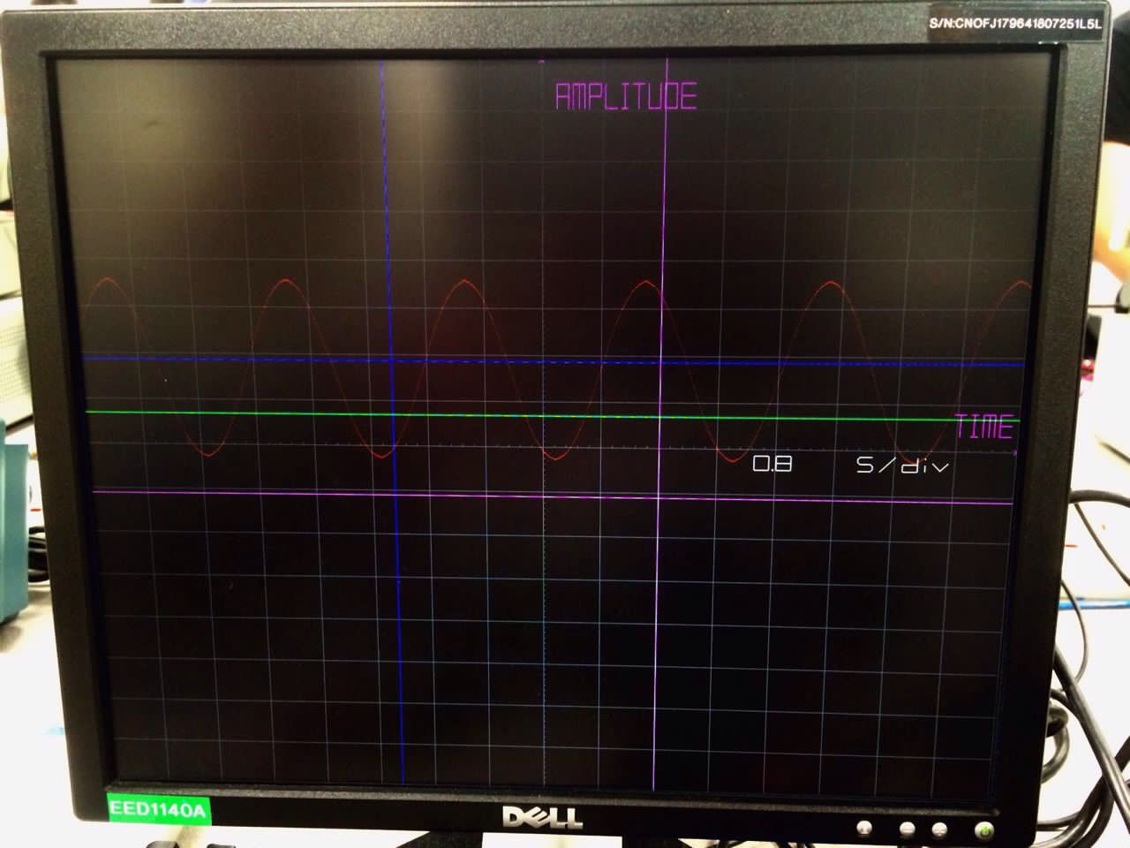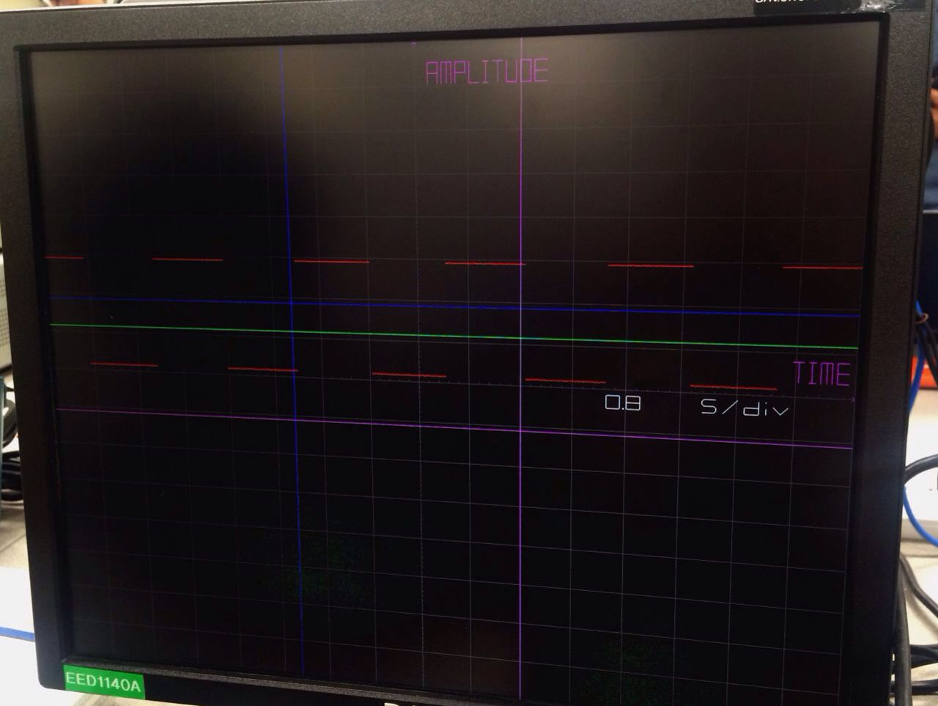

Fig.1 Picture of the monitor shows the Fig.2 Picture of the monitor shows the

sine waveform input at 0.8 s/division square waveform input at 0.8 s/division (time)

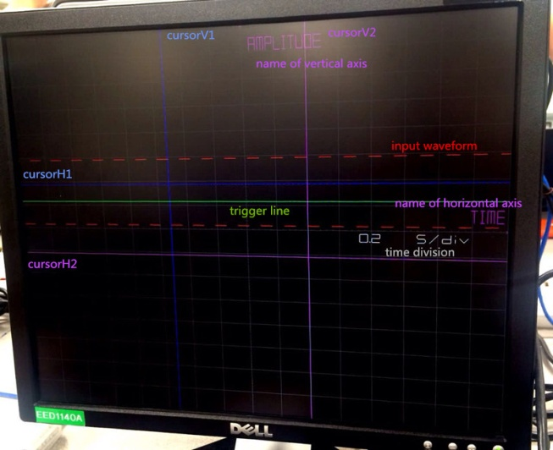 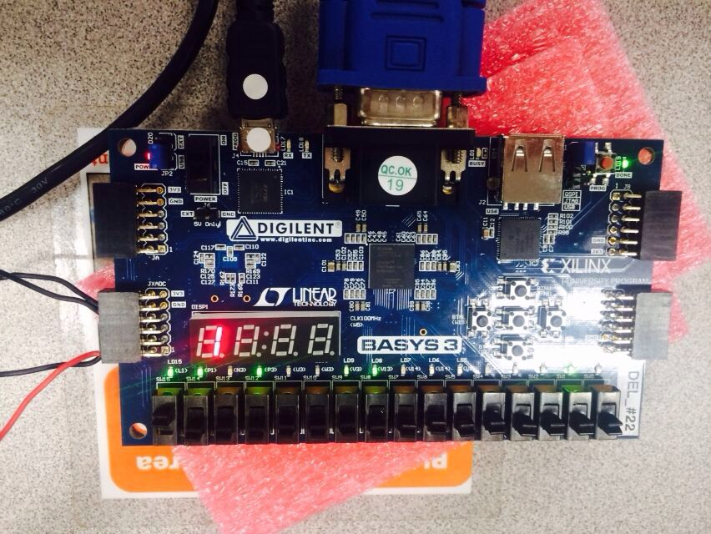

Fig3. Triggering the square waveform input at 0.2 s/division (time) (CLK_SUBSAMPLE_ID = 1)

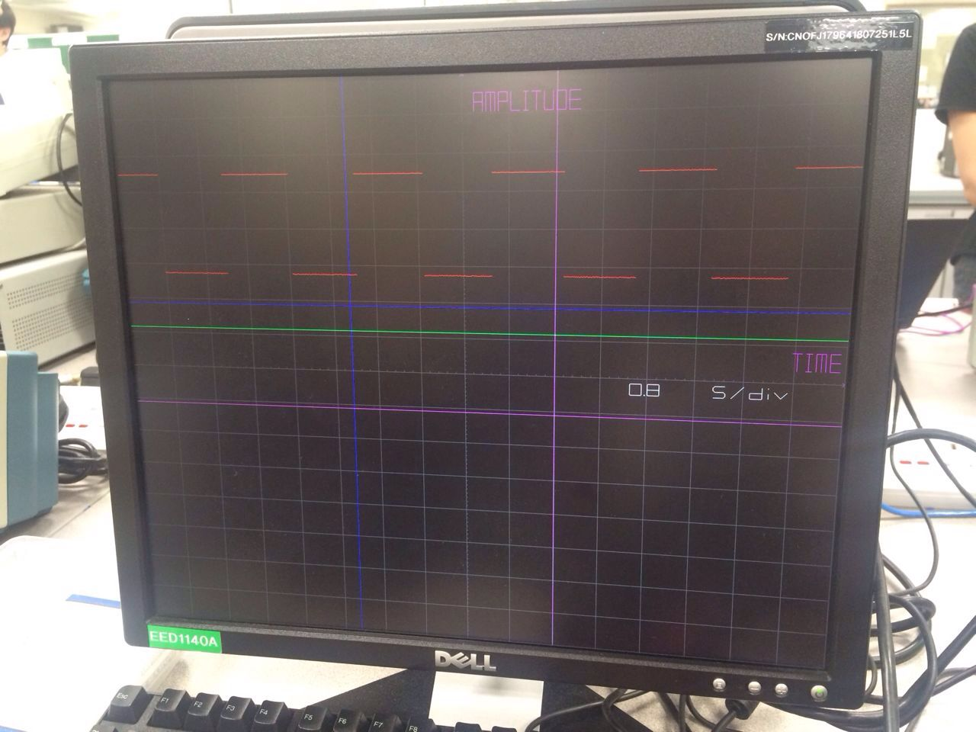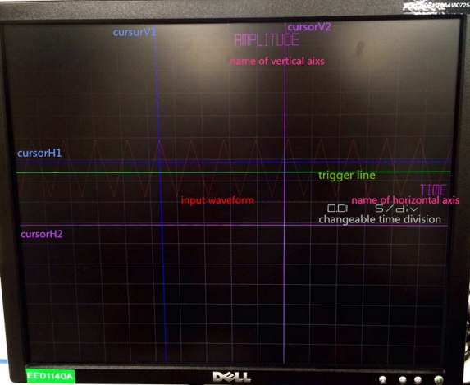

Fig4. Shift the input waveform upwards(downwards) Fig5.Triggering the input triangle waveform

1. Basic design:
2. Divide the screen into 16 * 16 grid
3. Draw ticks on the center-most horizontal grid line and the center-most vertical grid line, gives 5 sub-division in both directions
4. Display sine waveform, triangle waveform and square waveform signal on the monitor from left to right

1. Extra features:
2. Triggering the input high frequency signal up to 130 K Hz
3. Moveable cursors parallel to the time axis and amplitude axis in different colors
4. Adjust suitable time division for input signal and show the values of time division on the monitor
5. Show the values of CLK_SUBSAMPLE_ID by the first bit of 7 segment display on the FPGA board
6. Shift the wave form upwards and downwards
7. Label the time axis and amplitude axis
8. 1.1 Divide the screen into 16 * 16 grid

Draw ticks on the center-most horizontal grid line and the center-most vertical grid line, gives 5 sub-division in both directions

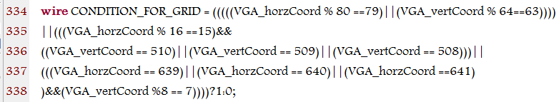Fig.a1 code for condition for grid and sub-division

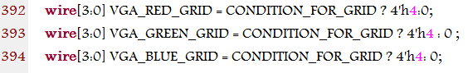

Fig. a2 Color for the grid and sub-division

* 1. Display sine waveform, triangle waveform and square waveform signal on the monitor from left to right

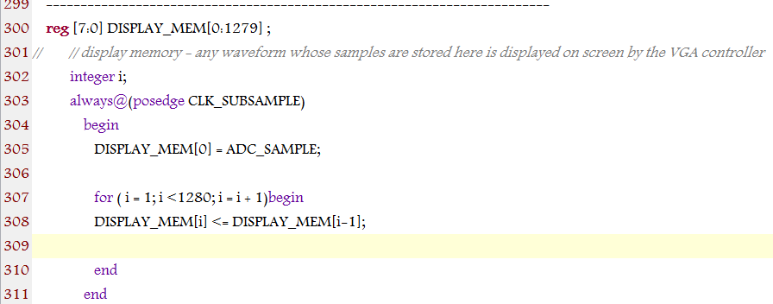

Fig.a3 Code for display the input waveform



Fig. a4 Code for the color of input waveform ( red )

1. 1. 1 Triggering the input high frequency signal up to 130 K Hz

Although adjust the time division will help users see the higher frequency input signal, the maximum frequency is still very limited for implementation. In order to deal with this problem, trigger will give users a clear and stable waveform show on the monitor. It’s going to provide users with a snapshot of the waveform.

The first condition for the trigger is the current ADC sample greater or equals to the trigger level(127). The second condition is the current ADC sample greater than the previous one.(positive trigger) Which means that the input signal will be triggered when the separated points of the input signal meet the trigger line (vertCood =127) first time after the frequency be changed.

In addition to obtain the high quality waveform on the monitor, the trigger level can be adjust by pressing the buttons when the SW14 is turn on. The BTNU button stands for increasing the trigger level by 15 units, similar to BTND. Since the trigger line (green) represents the value of the trigger level, it’s convent to see the position of the trigger level and it helps to adjust the trigger level to a suitable vale aim to obtain a stable waveform on the monitor.

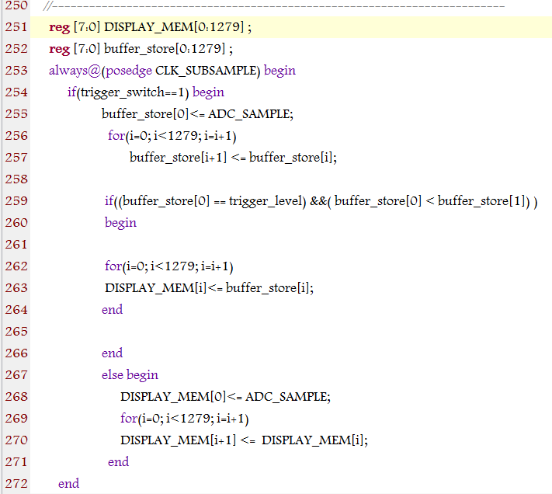

C:\Users\ADMINI~1\AppData\Local\Temp\36E5.tmp.png

Fig. b1&2 Code for trigger

1.2 Moveable cursors parallel to the time axis and amplitude axis in different colors

Cursor is a powerful tool of oscilloscope, it’s moveable and colorful help users to measure the amplitude and time difference and other values accurately.

CursorH1 and cursorV1(both in blue color) are controlled by the buttons under the SW13 turn on and SW12 turn off, similar cursorH2 and cursorV2(both in purple color) are controlled when the SW13 turn off and SW12 turn on. Both cursors H1 & H2 parallel to time axis are able to move upwards and downwards by pressing BTNU and BTND, cursors V1 & V2 are able to move left hand side and right hand side by pressing the BTNL and BTNR.

Cursors in same color means both of them are controlled by same switch, it’s easier for users to use the oscilloscope.

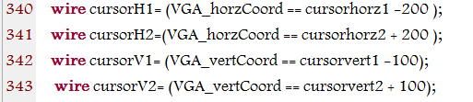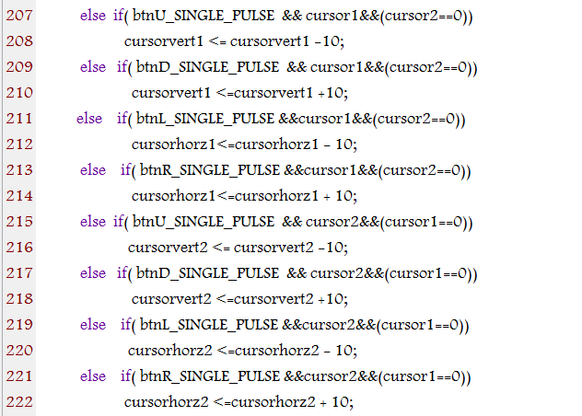

Fig. b3 code for display cursors Fig. b4 codes for shift cursors

* 1. Adjust suitable time division for input signal

Since the basic design of the oscilloscope cannot give users a smooth and easy waveform, when the frequency increases to a higher value the waveform will be a set of separated points. In order to prevent that change the time division will help user get a fluency waveform.

Increase the time division by pressing the BTNR button and decrease the time division by pressing the BTNL button. After adjust the CLL_SUBSAMPLE_ID, the corresponding LOAD_VALUE_SUBSAMPLE will be selected immediately. The clock divider function will generate the value of CLK_SUBSAMPL according to the value of LOAD_VALUE_SUBSAMPLE, then the waveform is able to scale by pressing the BTNL and BTUR buttons under the SW13 and SW12 turn off.

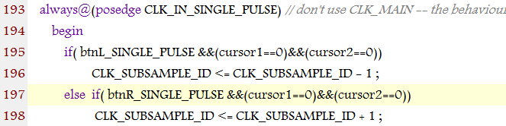 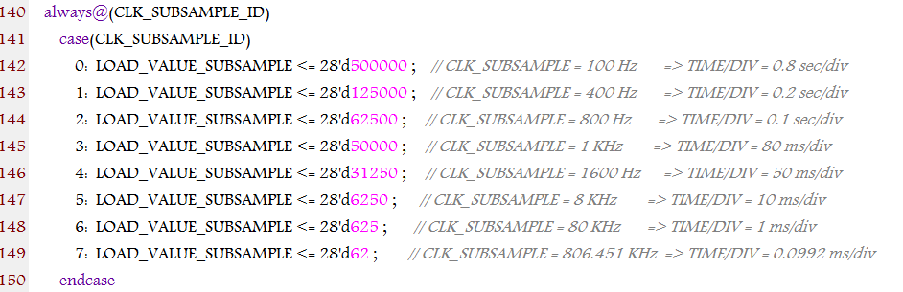

Fig. b5 adjust CLK_SUBSAMPLE_ID by push the buttons Fig. b6 Select LOAD_VALUE_SUBSAMPLE values

according to different values of CLK_SUBSAMPLE_ID

C:\Users\ADMINI~1\AppData\Local\Temp\4633.tmp.png

Fig. b7 Generate different values of CLK_SUBSAMPLE according to different LOAD_VALUE_SUBSAMPLE at different CLK_SUBSAMPLE_ID

* 1. Show the values of time division on the monitor

The purpose of show the changeable values of the time divisions on the monitor is make it able to calculate the time difference, period and frequency under different time divisions under the help of cursors.

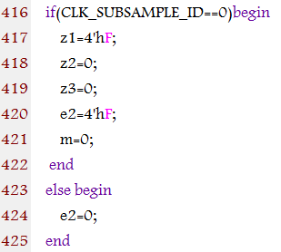 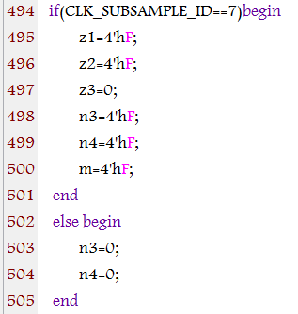

Fig. b8 code for case1, when CLK_SUBSAMPLE_ID =0 Fig. b9 code for case7, when the CLOCK_SUBSAMPLE_ID = 7

Z1 stands for the MSB of the 4 digits equals to zero, e2 stands for the second digit of the 4 digits equals to eight.

Similarly n3 stands for the 3rd digit and n4 stands for 4th digit, m stands for 5th bits m in millisecond.

1.5 Show the values of CLK_SUBSAMPLE_ID by the first bit of 7 segment display on the FPGA board

It’s very meaningful for designer debug the code, see if the value of the time division showed on the screen is matching to the CLK_SUBSAMPLE_ID or not. Also very meaningfully for the user to know which state(there are 8 states, from 0 to 7) they stay in the time division, if users see the ID values it more convent to know what’s the next state. And the time division should increase(decrease) to which value if he press the buttons.

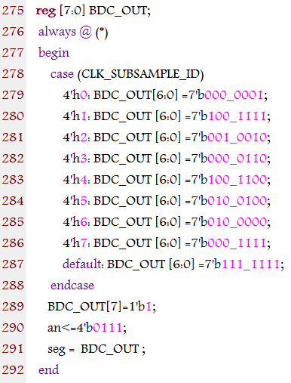 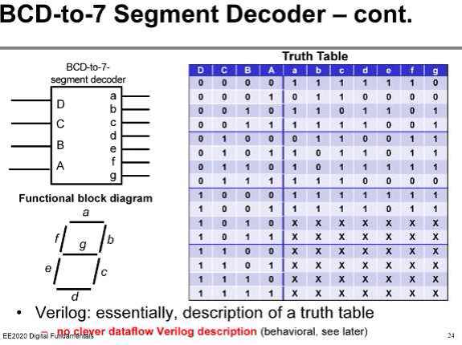

Fig.b10 code for the 7 segment number Fig. b11 truth table for 7 segment display

an =4’b0111, since the design is use the leftmost 7 segment display light , MSB is zero because active low signal is used.

According to the truth table, assign BDC_OUT[6:0] to different numbers , active low signal be used here.

* 1. Shift the waveform upwards and downwards

Shift the waveform upwards and downwards is meaningful when not only single input signal but also two channels input signal. Shift one of the input signals can prevent the overlap of the signals in order to see two separated clear signals at the same time. It’s also a necessary feature for two channel oscilloscope.

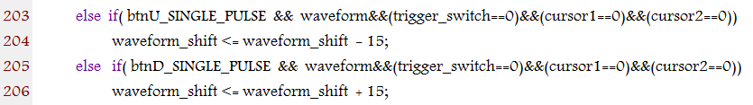

Fig. b12&13 codes for shift waveform upwards and down wards

The oscilloscope is able to shift the waveform upwards and downwards by pressing the BTNU and BTND buttons under the SW14 turn on and SW15, SW13 and SW12 turn off.

* 1. Label the time axis and amplitude axis

It’s compulsory to label the axis help users to identify which axis stands for which physical quantity. For the oscilloscope the horizontal axis stands for the time and the vertical axis stands for the amplitude.

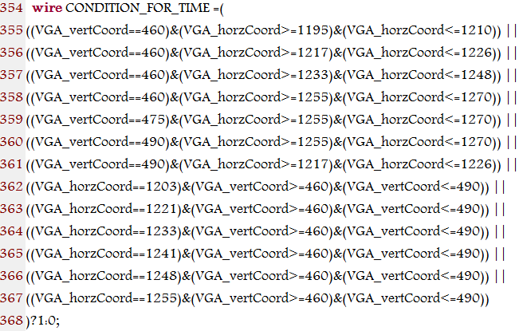 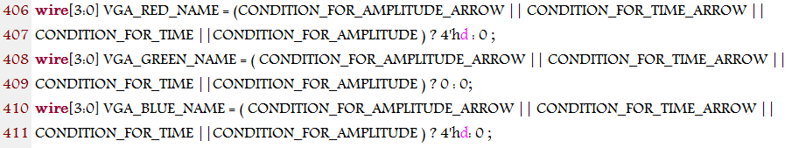

Fig. b14 code for the condition for the time Fig. b15 code for assign the color for the time and amplitude

Feedback for EE2020 individual project:

The whole project is very enjoyable. Especially for self design the extra feature part, it’s very helpful to improve our self study ability. And the whole project is schedule is good, give us enough time to develop the project. But the software has some problem, is it possible to use another software? And the helps from GA is also a very important factor for students’ projects, GA should know well about the professional knowledge. Thanks all of the officers in Digital lab! ☺